Assignment 5

Nithin varma

2022-12-01

Cerealsdata <- read.csv("C:/Users/Kittu Varma/Downloads/Cereals.csv")

library(fastDummies)

## Warning: package 'fastDummies' was built under R version 4.2.2

library(caret)

## Loading required package: ggplot2

## Loading required package: lattice

library(car)

## Warning: package 'car' was built under R version 4.2.2

## Loading required package: carData

## Warning: package 'carData' was built under R version 4.2.2

library(tidyverse)

## Warning: package 'tidyverse' was built under R version 4.2.2

## ── Attaching packages  
## ───────────────────────────────────────  
## tidyverse 1.3.2 ──

## ✔ tibble 3.1.8 ✔ dplyr 1.0.10  
## ✔ tidyr 1.2.1 ✔ stringr 1.4.1   
## ✔ readr 2.1.3 ✔ forcats 0.5.2   
## ✔ purrr 0.3.4

## Warning: package 'forcats' was built under R version 4.2.2

## ── Conflicts ────────────────────────────────────────── tidyverse_conflicts() ──  
## ✖ dplyr::filter() masks stats::filter()  
## ✖ dplyr::lag() masks stats::lag()  
## ✖ purrr::lift() masks caret::lift()  
## ✖ dplyr::recode() masks car::recode()  
## ✖ purrr::some() masks car::some()

library(cluster)  
library(stats)  
library(factoextra)

## Warning: package 'factoextra' was built under R version 4.2.2

## Welcome! Want to learn more? See two factoextra-related books at https://goo.gl/ve3WBa

library(cluster)  
library(hrbrthemes)

## Warning: package 'hrbrthemes' was built under R version 4.2.2

## NOTE: Either Arial Narrow or Roboto Condensed fonts are required to use these themes.  
## Please use hrbrthemes::import_roboto_condensed() to install Roboto Condensed and  
## if Arial Narrow is not on your system, please see https://bit.ly/arialnarrow

library(GGally)

## Warning: package 'GGally' was built under R version 4.2.2

## Registered S3 method overwritten by 'GGally':  
## method from   
## +.gg ggplot2

library(viridis)

## Warning: package 'viridis' was built under R version 4.2.2

## Loading required package: viridisLite

library(fpc)

## Warning: package 'fpc' was built under R version 4.2.2

library(caTools)

## Warning: package 'caTools' was built under R version 4.2.2

#DataPreprocessing

#Removing all cereals with missing values

Cerealsdata<-na.omit(Cerealsdata)

#Confirming that each record is unique

record<- as.data.frame(table(Cerealsdata[1]))

#Adding row names

row.names(Cerealsdata)<- Cerealsdata[,1]

#removing the name coloums

Cerealsdata<-Cerealsdata[,-1]

#reviewing data structure

str(Cerealsdata)

## 'data.frame': 74 obs. of 15 variables:  
## $ mfr : chr "N" "Q" "K" "K" ...  
## $ type : chr "C" "C" "C" "C" ...  
## $ calories: int 70 120 70 50 110 110 130 90 90 120 ...  
## $ protein : int 4 3 4 4 2 2 3 2 3 1 ...  
## $ fat : int 1 5 1 0 2 0 2 1 0 2 ...  
## $ sodium : int 130 15 260 140 180 125 210 200 210 220 ...  
## $ fiber : num 10 2 9 14 1.5 1 2 4 5 0 ...  
## $ carbo : num 5 8 7 8 10.5 11 18 15 13 12 ...  
## $ sugars : int 6 8 5 0 10 14 8 6 5 12 ...  
## $ potass : int 280 135 320 330 70 30 100 125 190 35 ...  
## $ vitamins: int 25 0 25 25 25 25 25 25 25 25 ...  
## $ shelf : int 3 3 3 3 1 2 3 1 3 2 ...  
## $ weight : num 1 1 1 1 1 1 1.33 1 1 1 ...  
## $ cups : num 0.33 1 0.33 0.5 0.75 1 0.75 0.67 0.67 0.75 ...  
## $ rating : num 68.4 34 59.4 93.7 29.5 ...

#Apply hierarchical clustering to the cereals data using Euclidean distance to the normalized measurements.

distance <- dist(Cerealsdata, method = "euclidean")

## Warning in dist(Cerealsdata, method = "euclidean"): NAs introduced by coercion

# Hierarchical clustering using Complete Linkage  
hc1 <- hclust(distance, method = "complete")  
# Plot the obtained dendrogram  
plot(hc1, cex = 0.6, hang = -1, main = "Dendogram_complete")

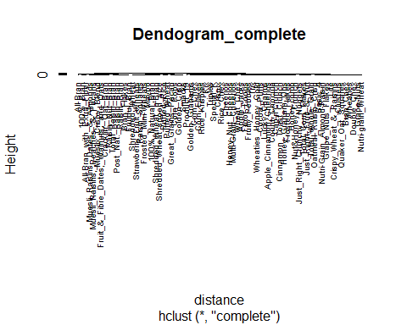

#Use Agnes to compare the clustering from single linkage, complete linkage, average linkage, and Ward. Choose the best method.

# vector of methods to compare  
m <- c( "average", "single", "complete", "ward")  
names(m) <- c( "average", "single", "complete", "ward")  
# function to compute coefficient  
ac <- function(x) {  
agnes(Cerealsdata, method = x)$ac  
}  
map_dbl(m, ac)

## average single complete ward   
## 0.8786692 0.7297141 0.9225732 0.9595040

#ward linkage has the strongest clustering structure

hc3<-hclust(distance,method = "ward.D2")  
plot(hc3, cex = 0.7, hang = -1, main = "Dendogram_Agnes")

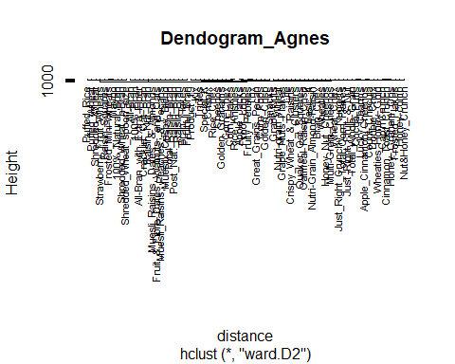

#differnece between Hieracial clustering and K means is that: K-Means is that it needs us to pre-enter the number of clusters (K) but Hierarchical clustering has no such requirements to do so.

#How many clusters would you choose? #based on data exploration we have 7 clusters that appear to be common among the paired variables #Cut them into 7 clusters

clusters <- cutree(hc3, k = 7)  
#number of cereals in each cluster  
table(clusters)

## clusters  
## 1 2 3 4 5 6 7   
## 3 10 31 8 5 11 6

#cluster data with k=4

clusters1 <- cutree(hc3, k = 4)  
#number of cereals in each cluster  
table(clusters1)

## clusters1  
## 1 2 3 4   
## 14 10 39 11

#cluster centroids  
centroids_cereals <- aggregate(Cerealsdata, by=list(cluster=clusters1), mean)

## Warning in mean.default(X[[i]], ...): argument is not numeric or logical:  
## returning NA  
  
## Warning in mean.default(X[[i]], ...): argument is not numeric or logical:  
## returning NA  
  
## Warning in mean.default(X[[i]], ...): argument is not numeric or logical:  
## returning NA  
  
## Warning in mean.default(X[[i]], ...): argument is not numeric or logical:  
## returning NA  
  
## Warning in mean.default(X[[i]], ...): argument is not numeric or logical:  
## returning NA  
  
## Warning in mean.default(X[[i]], ...): argument is not numeric or logical:  
## returning NA  
  
## Warning in mean.default(X[[i]], ...): argument is not numeric or logical:  
## returning NA  
  
## Warning in mean.default(X[[i]], ...): argument is not numeric or logical:  
## returning NA

centroids_cereals

## cluster mfr type calories protein fat sodium fiber carbo  
## 1 1 NA NA 112.1429 3.357143 1.4285714 172.5000 5.6071429 12.03571  
## 2 2 NA NA 86.0000 2.500000 0.6000000 3.0000 2.1000000 14.60000  
## 3 3 NA NA 110.2564 2.179487 1.1025641 169.7436 1.4230769 14.26923  
## 4 4 NA NA 108.1818 2.636364 0.4545455 268.1818 0.5454545 19.90909  
## sugars potass vitamins shelf weight cups rating  
## 1 9.142857 217.14286 30.35714 2.928571 1.160000 0.6614286 46.01532  
## 2 2.900000 95.00000 10.00000 2.100000 0.883000 0.8640000 60.11492  
## 3 8.564103 71.66667 32.69231 2.128205 1.031026 0.8082051 36.55985  
## 4 3.181818 45.90909 31.81818 1.727273 1.000000 1.0345455 42.21039

#putting the data all together to identify which cluster each cereal belongs to  
cereal.cluster <- cbind(clusters1, Cerealsdata)  
#plot cluster  
plot(hc3, cex= 0.6, hang = -1)  
#Plot clusters with borders  
rect.hclust(hc3, k = 4, border = 2:7)  
abline(h = 14, col = "black")

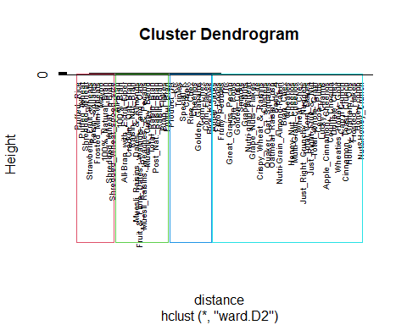

#cluster centroids

centroids_cerealsdata <- aggregate(Cerealsdata, by=list(cluster=clusters1), mean)

## Warning in mean.default(X[[i]], ...): argument is not numeric or logical:  
## returning NA  
  
## Warning in mean.default(X[[i]], ...): argument is not numeric or logical:  
## returning NA  
  
## Warning in mean.default(X[[i]], ...): argument is not numeric or logical:  
## returning NA  
  
## Warning in mean.default(X[[i]], ...): argument is not numeric or logical:  
## returning NA  
  
## Warning in mean.default(X[[i]], ...): argument is not numeric or logical:  
## returning NA  
  
## Warning in mean.default(X[[i]], ...): argument is not numeric or logical:  
## returning NA  
  
## Warning in mean.default(X[[i]], ...): argument is not numeric or logical:  
## returning NA  
  
## Warning in mean.default(X[[i]], ...): argument is not numeric or logical:  
## returning NA

centroids_cerealsdata

## cluster mfr type calories protein fat sodium fiber carbo  
## 1 1 NA NA 112.1429 3.357143 1.4285714 172.5000 5.6071429 12.03571  
## 2 2 NA NA 86.0000 2.500000 0.6000000 3.0000 2.1000000 14.60000  
## 3 3 NA NA 110.2564 2.179487 1.1025641 169.7436 1.4230769 14.26923  
## 4 4 NA NA 108.1818 2.636364 0.4545455 268.1818 0.5454545 19.90909  
## sugars potass vitamins shelf weight cups rating  
## 1 9.142857 217.14286 30.35714 2.928571 1.160000 0.6614286 46.01532  
## 2 2.900000 95.00000 10.00000 2.100000 0.883000 0.8640000 60.11492  
## 3 8.564103 71.66667 32.69231 2.128205 1.031026 0.8082051 36.55985  
## 4 3.181818 45.90909 31.81818 1.727273 1.000000 1.0345455 42.21039

# partition data into A and B - 50% (data has 74rows)  
set.seed(123)  
A<-Cerealsdata[1:37,]  
B<-Cerealsdata[38:74,]

#clustering partition A # Apply hierarchical clustering using Euclidean distance

distanceA <- dist(A, method = "euclidean")

## Warning in dist(A, method = "euclidean"): NAs introduced by coercion

#Hierarchical clustering using Ward (we had determined that ward had the strongest clustering structure)  
hc_A <- hclust(distanceA, method = "ward.D2")  
# Cut tree into 4 groups(we had determined that optimal k =4)  
clust_A <- cutree(hc_A, k = 4)  
# Number of members in each cluster  
table(clust_A)

## clust_A  
## 1 2 3 4   
## 7 4 13 13

#putting all the data together to identify which cluster each cereal belongs to

clust_A1 <- cbind(clust_A, A)  
plot(hc_A, cex= 0.6, hang = -1)  
#Plot clusters with borders  
rect.hclust(hc_A, k = 4, border = 2:7)  
abline(h = 10.3, col = "black")

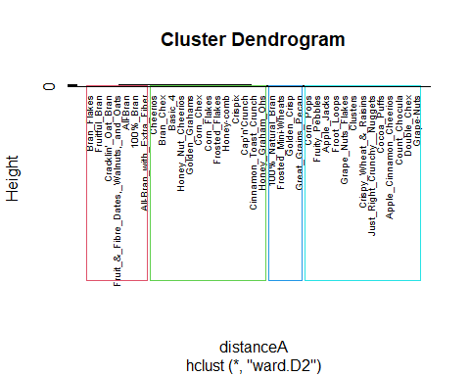

# calculating centroids of partition A

A<-as.data.frame(A)  
centroids_A <- aggregate(A, by=list(cluster=clust_A), mean)

## Warning in mean.default(X[[i]], ...): argument is not numeric or logical:  
## returning NA  
  
## Warning in mean.default(X[[i]], ...): argument is not numeric or logical:  
## returning NA  
  
## Warning in mean.default(X[[i]], ...): argument is not numeric or logical:  
## returning NA  
  
## Warning in mean.default(X[[i]], ...): argument is not numeric or logical:  
## returning NA  
  
## Warning in mean.default(X[[i]], ...): argument is not numeric or logical:  
## returning NA  
  
## Warning in mean.default(X[[i]], ...): argument is not numeric or logical:  
## returning NA  
  
## Warning in mean.default(X[[i]], ...): argument is not numeric or logical:  
## returning NA  
  
## Warning in mean.default(X[[i]], ...): argument is not numeric or logical:  
## returning NA

#assign each record in partition B to the cluster with the closest centroid).

Assign<-data.frame(observations=seq(1,37,1),cluster=rep(0,37))  
for(i in 0:37)  
{  
x<-as.data.frame(rbind(centroids_A[,-1],B[i,]))  
y<-as.matrix(get_dist(x))  
Assign[i,2]<-which.min(y[4,-4])  
}

## Warning in stats::dist(x, method = method, ...): NAs introduced by coercion  
  
## Warning in stats::dist(x, method = method, ...): NAs introduced by coercion  
  
## Warning in stats::dist(x, method = method, ...): NAs introduced by coercion  
  
## Warning in stats::dist(x, method = method, ...): NAs introduced by coercion  
  
## Warning in stats::dist(x, method = method, ...): NAs introduced by coercion  
  
## Warning in stats::dist(x, method = method, ...): NAs introduced by coercion  
  
## Warning in stats::dist(x, method = method, ...): NAs introduced by coercion  
  
## Warning in stats::dist(x, method = method, ...): NAs introduced by coercion  
  
## Warning in stats::dist(x, method = method, ...): NAs introduced by coercion  
  
## Warning in stats::dist(x, method = method, ...): NAs introduced by coercion  
  
## Warning in stats::dist(x, method = method, ...): NAs introduced by coercion  
  
## Warning in stats::dist(x, method = method, ...): NAs introduced by coercion  
  
## Warning in stats::dist(x, method = method, ...): NAs introduced by coercion  
  
## Warning in stats::dist(x, method = method, ...): NAs introduced by coercion  
  
## Warning in stats::dist(x, method = method, ...): NAs introduced by coercion  
  
## Warning in stats::dist(x, method = method, ...): NAs introduced by coercion  
  
## Warning in stats::dist(x, method = method, ...): NAs introduced by coercion  
  
## Warning in stats::dist(x, method = method, ...): NAs introduced by coercion  
  
## Warning in stats::dist(x, method = method, ...): NAs introduced by coercion  
  
## Warning in stats::dist(x, method = method, ...): NAs introduced by coercion  
  
## Warning in stats::dist(x, method = method, ...): NAs introduced by coercion  
  
## Warning in stats::dist(x, method = method, ...): NAs introduced by coercion  
  
## Warning in stats::dist(x, method = method, ...): NAs introduced by coercion  
  
## Warning in stats::dist(x, method = method, ...): NAs introduced by coercion  
  
## Warning in stats::dist(x, method = method, ...): NAs introduced by coercion  
  
## Warning in stats::dist(x, method = method, ...): NAs introduced by coercion  
  
## Warning in stats::dist(x, method = method, ...): NAs introduced by coercion  
  
## Warning in stats::dist(x, method = method, ...): NAs introduced by coercion  
  
## Warning in stats::dist(x, method = method, ...): NAs introduced by coercion  
  
## Warning in stats::dist(x, method = method, ...): NAs introduced by coercion  
  
## Warning in stats::dist(x, method = method, ...): NAs introduced by coercion  
  
## Warning in stats::dist(x, method = method, ...): NAs introduced by coercion  
  
## Warning in stats::dist(x, method = method, ...): NAs introduced by coercion  
  
## Warning in stats::dist(x, method = method, ...): NAs introduced by coercion  
  
## Warning in stats::dist(x, method = method, ...): NAs introduced by coercion  
  
## Warning in stats::dist(x, method = method, ...): NAs introduced by coercion  
  
## Warning in stats::dist(x, method = method, ...): NAs introduced by coercion

rownames(Assign) <-rownames(B)  
table(Assign)

## cluster  
## observations 3 4  
## 1 1 0  
## 2 0 1  
## 3 1 0  
## 4 0 1  
## 5 1 0  
## 6 1 0  
## 7 1 0  
## 8 1 0  
## 9 0 1  
## 10 0 1  
## 11 0 1  
## 12 0 1  
## 13 1 0  
## 14 1 0  
## 15 1 0  
## 16 1 0  
## 17 1 0  
## 18 1 0  
## 19 1 0  
## 20 1 0  
## 21 1 0  
## 22 0 1  
## 23 0 1  
## 24 1 0  
## 25 1 0  
## 26 1 0  
## 27 1 0  
## 28 0 1  
## 29 1 0  
## 30 1 0  
## 31 1 0  
## 32 1 0  
## 33 0 1  
## 34 1 0  
## 35 0 1  
## 36 0 1  
## 37 0 1

cbind(cluster_partition=Assign$cluster,cluster_complete=cereal.cluster[38:74,1])

## cluster_partition cluster_complete  
## [1,] 3 3  
## [2,] 4 4  
## [3,] 3 3  
## [4,] 4 3  
## [5,] 3 2  
## [6,] 3 1  
## [7,] 3 1  
## [8,] 3 1  
## [9,] 4 3  
## [10,] 4 3  
## [11,] 4 3  
## [12,] 4 3  
## [13,] 3 3  
## [14,] 3 1  
## [15,] 3 4  
## [16,] 3 2  
## [17,] 3 2  
## [18,] 3 3  
## [19,] 3 1  
## [20,] 3 1  
## [21,] 3 2  
## [22,] 4 4  
## [23,] 4 4  
## [24,] 3 2  
## [25,] 3 2  
## [26,] 3 2  
## [27,] 3 3  
## [28,] 4 4  
## [29,] 3 2  
## [30,] 3 3  
## [31,] 3 1  
## [32,] 3 3  
## [33,] 4 4  
## [34,] 3 3  
## [35,] 4 3  
## [36,] 4 3  
## [37,] 4 3

table(Assign$cluster==cereal.cluster[38:74,1])

##   
## FALSE TRUE   
## 24 13

#59% of data was assigned to the same cluster with both partitioned data and complete data.this representsthe stability of the cluster, which is not too high. however, centroids were used for assigning clusters in partitioned dataset whereas in the complete dataset, total figures were used.

## * Cluster stability assessment *

## Cluster method: hclust/cutree

## Full clustering results are given as parameter result

## of the clusterboot object, which also provides further statistics

## of the resampling results.

## Number of resampling runs: 100

## Number of clusters found in data: 4

colnames(Cerealsdata)

## [1] "mfr" "type" "calories" "protein" "fat" "sodium"   
## [7] "fiber" "carbo" "sugars" "potass" "vitamins" "shelf"   
## [13] "weight" "cups" "rating"

#Healthy variables are Protein; Fiber; Potass; Vitamins. #Unhealthy variables are Sugars; calories;

centroids_cereals

## cluster mfr type calories protein fat sodium fiber carbo  
## 1 1 NA NA 112.1429 3.357143 1.4285714 172.5000 5.6071429 12.03571  
## 2 2 NA NA 86.0000 2.500000 0.6000000 3.0000 2.1000000 14.60000  
## 3 3 NA NA 110.2564 2.179487 1.1025641 169.7436 1.4230769 14.26923  
## 4 4 NA NA 108.1818 2.636364 0.4545455 268.1818 0.5454545 19.90909  
## sugars potass vitamins shelf weight cups rating  
## 1 9.142857 217.14286 30.35714 2.928571 1.160000 0.6614286 46.01532  
## 2 2.900000 95.00000 10.00000 2.100000 0.883000 0.8640000 60.11492  
## 3 8.564103 71.66667 32.69231 2.128205 1.031026 0.8082051 36.55985  
## 4 3.181818 45.90909 31.81818 1.727273 1.000000 1.0345455 42.21039

#cluster 1 is highest in Protein; fiber; Potass and lowest in Sugar and calories. Cluster 1 has the healthy cereals.

summary(Cerealsdata)

## mfr type calories protein   
## Length:74 Length:74 Min. : 50 Min. :1.000   
## Class :character Class :character 1st Qu.:100 1st Qu.:2.000   
## Mode :character Mode :character Median :110 Median :2.500   
## Mean :107 Mean :2.514   
## 3rd Qu.:110 3rd Qu.:3.000   
## Max. :160 Max. :6.000   
## fat sodium fiber carbo sugars   
## Min. :0 Min. : 0.0 Min. : 0.000 Min. : 5.00 Min. : 0.000   
## 1st Qu.:0 1st Qu.:135.0 1st Qu.: 0.250 1st Qu.:12.00 1st Qu.: 3.000   
## Median :1 Median :180.0 Median : 2.000 Median :14.50 Median : 7.000   
## Mean :1 Mean :162.4 Mean : 2.176 Mean :14.73 Mean : 7.108   
## 3rd Qu.:1 3rd Qu.:217.5 3rd Qu.: 3.000 3rd Qu.:17.00 3rd Qu.:11.000   
## Max. :5 Max. :320.0 Max. :14.000 Max. :23.00 Max. :15.000   
## potass vitamins shelf weight   
## Min. : 15.00 Min. : 0.00 Min. :1.000 Min. :0.500   
## 1st Qu.: 41.25 1st Qu.: 25.00 1st Qu.:1.250 1st Qu.:1.000   
## Median : 90.00 Median : 25.00 Median :2.000 Median :1.000   
## Mean : 98.51 Mean : 29.05 Mean :2.216 Mean :1.031   
## 3rd Qu.:120.00 3rd Qu.: 25.00 3rd Qu.:3.000 3rd Qu.:1.000   
## Max. :330.00 Max. :100.00 Max. :3.000 Max. :1.500   
## cups rating   
## Min. :0.2500 Min. :18.04   
## 1st Qu.:0.6700 1st Qu.:32.45   
## Median :0.7500 Median :40.25   
## Mean :0.8216 Mean :42.37   
## 3rd Qu.:1.0000 3rd Qu.:50.52   
## Max. :1.5000 Max. :93.70